Title:Fire Weather Index Predictor
(A Machine Learning model to predict Fire Weather)



Infosys Springboard Virtual Internship Program

Submitted By
Vanshika Yadav

Under the guidance of Mentor Praveen

Project Statement
This project focuses on building a Fire Weather Index (FWI) Predictor that estimates wildfire risk using essential environmental and fire-danger features such as temperature, relative humidity, wind speed, rainfall, FFMC, DMC, DC, ISI, and BUI. The dataset is thoroughly cleaned, pre-processed, and analysed to ensure reliable inputs, followed by visual exploration to understand feature distributions and relationships. Machine learning techniques are then applied to learn how weather conditions influence fire danger levels, enabling accurate prediction of the FWI value. The system also incorporates regional information to study area-wise fire behaviour and improve prediction relevance. Overall, the model aims to support early detection, risk assessment, and informed decision-making for effective wildfire management.

Expected Outcome
• A predictive ML model trained using Ridge Regression to forecast FWI.
• A Flask-based web app where users can input environmental values and get FWI predictions.
• A system that can help forest departments, emergency planners, and climate researchers make data-driven decisions.

Modules to be Implemented
• Data Collection
• Data Exploration (EDA) and Data Preprocessing
• Feature Engineering and Scaling
• Model Training using Ridge Regression
• Evaluation and Optimisation
• Deployment via Flask App
• Presentation and Documentation

System Requirements
Software:
- Python
- Python libraries (pandas, numpy, matplotlib, seaborn, sklearn, math)
- Flask

Milestone 1(Week 1,2)
- Module 1 (Data Collection)

The dataset was collected by exploring multiple online sources and selecting one that contained the essential environmental features required for FWI prediction, including Temperature, Relative Humidity, Wind Speed, Rain, FFMC, DMC, ISI, and Region. After loading the chosen dataset into a Pandas DataFrame, an initial inspection was carried out to understand its structure and quality. This included checking datatypes, identifying null values, reviewing memory usage, and generating statistical summaries to examine the distribution and range of numerical features. The dataset’s shape and duplicate entries were also analysed to ensure completeness and reliability, providing a solid foundation for further preprocessing and modelling.

Conducted initial inspection to understand feature distributions and data quality.

- Load the dataset
import pandas as pd
import numpy as np
import matplotlib.pyplot as plt
from sklearn.preprocessing import LabelEncoder
import seaborn as sns
import math

data=pd.read_csv("C:\Users\Admin\Desktop\FWI Dataset.csv")
print(data.head())

- Verify Datatypes

df.info()

<class 'pandas.core.frame.DataFrame'>
RangeIndex: 244 entries, 0 to 243
Data columns (total 15 columns):
# Column Non-Null Count Dtype
--- ------ -------------- -----
0 day 244 non-null int64
1 month 244 non-null int64
2 year 244 non-null int64
3 Temperature 244 non-null int64
4 RH 244 non-null int64
5 Ws 244 non-null int64
6 Rain 244 non-null float64
7 FFMC 244 non-null float64
8 DMC 244 non-null float64
9 DC 244 non-null object
10 ISI 244 non-null float64
11 BUI 244 non-null float64
12 FWI 244 non-null object
13 Classes 243 non-null object
14 Region 244 non-null object
dtypes: float64(5), int64(6), object(4)
memory usage: 28.7+ KB

- Module 2 (Data Exploration (EDA) and Data Preprocessing)

During the preprocessing stage, the dataset was first examined for missing or null values, and appropriate handling techniques were applied to ensure completeness. Outlier detection was then performed using boxplots and statistical thresholds to identify abnormal values that could affect model performance. To better understand feature behaviour, data distributions were visualised through histograms and density plots, while correlation matrices and scatterplots were used to explore relationships between variables. Categorical features, such as Region, were encoded using label encoding to make them suitable for machine learning algorithms. Finally, the cleaned and processed dataset was saved for use in building and evaluating predictive models.

- Handle missing values

df.isnull().sum()

day 0
month 0
year 0
Temperature 0
RH 0
Ws 0
Rain 0
FFMC 0
DMC 0
DC 0
ISI 0
BUI 0
FWI 0
Classes 0
region 0
dtype: int64

A missing-value check was performed to identify incomplete records, revealing that only one row contained a null value in the Classes column. This validation helped ensure data completeness and supported appropriate handling before further preprocessing.

- Density Plot, Scatter Plot, Pairplot, Subplot

The Density Plot is a smoothed version of a histogram that helps us visualize the distribution of numeric variables over a continuous interval. In this project, we use it to observe the probability density of features like Temperature, Relative Humidity (RH), and Wind Speed. It allows us to see where values are concentrated and identify the "skewness" of the data without the noise of individual histogram bins.
Technical Implementation: We utilize sns.kdeplot() or the kind='kde' parameter within pandas to generate these visualizations for each feature.
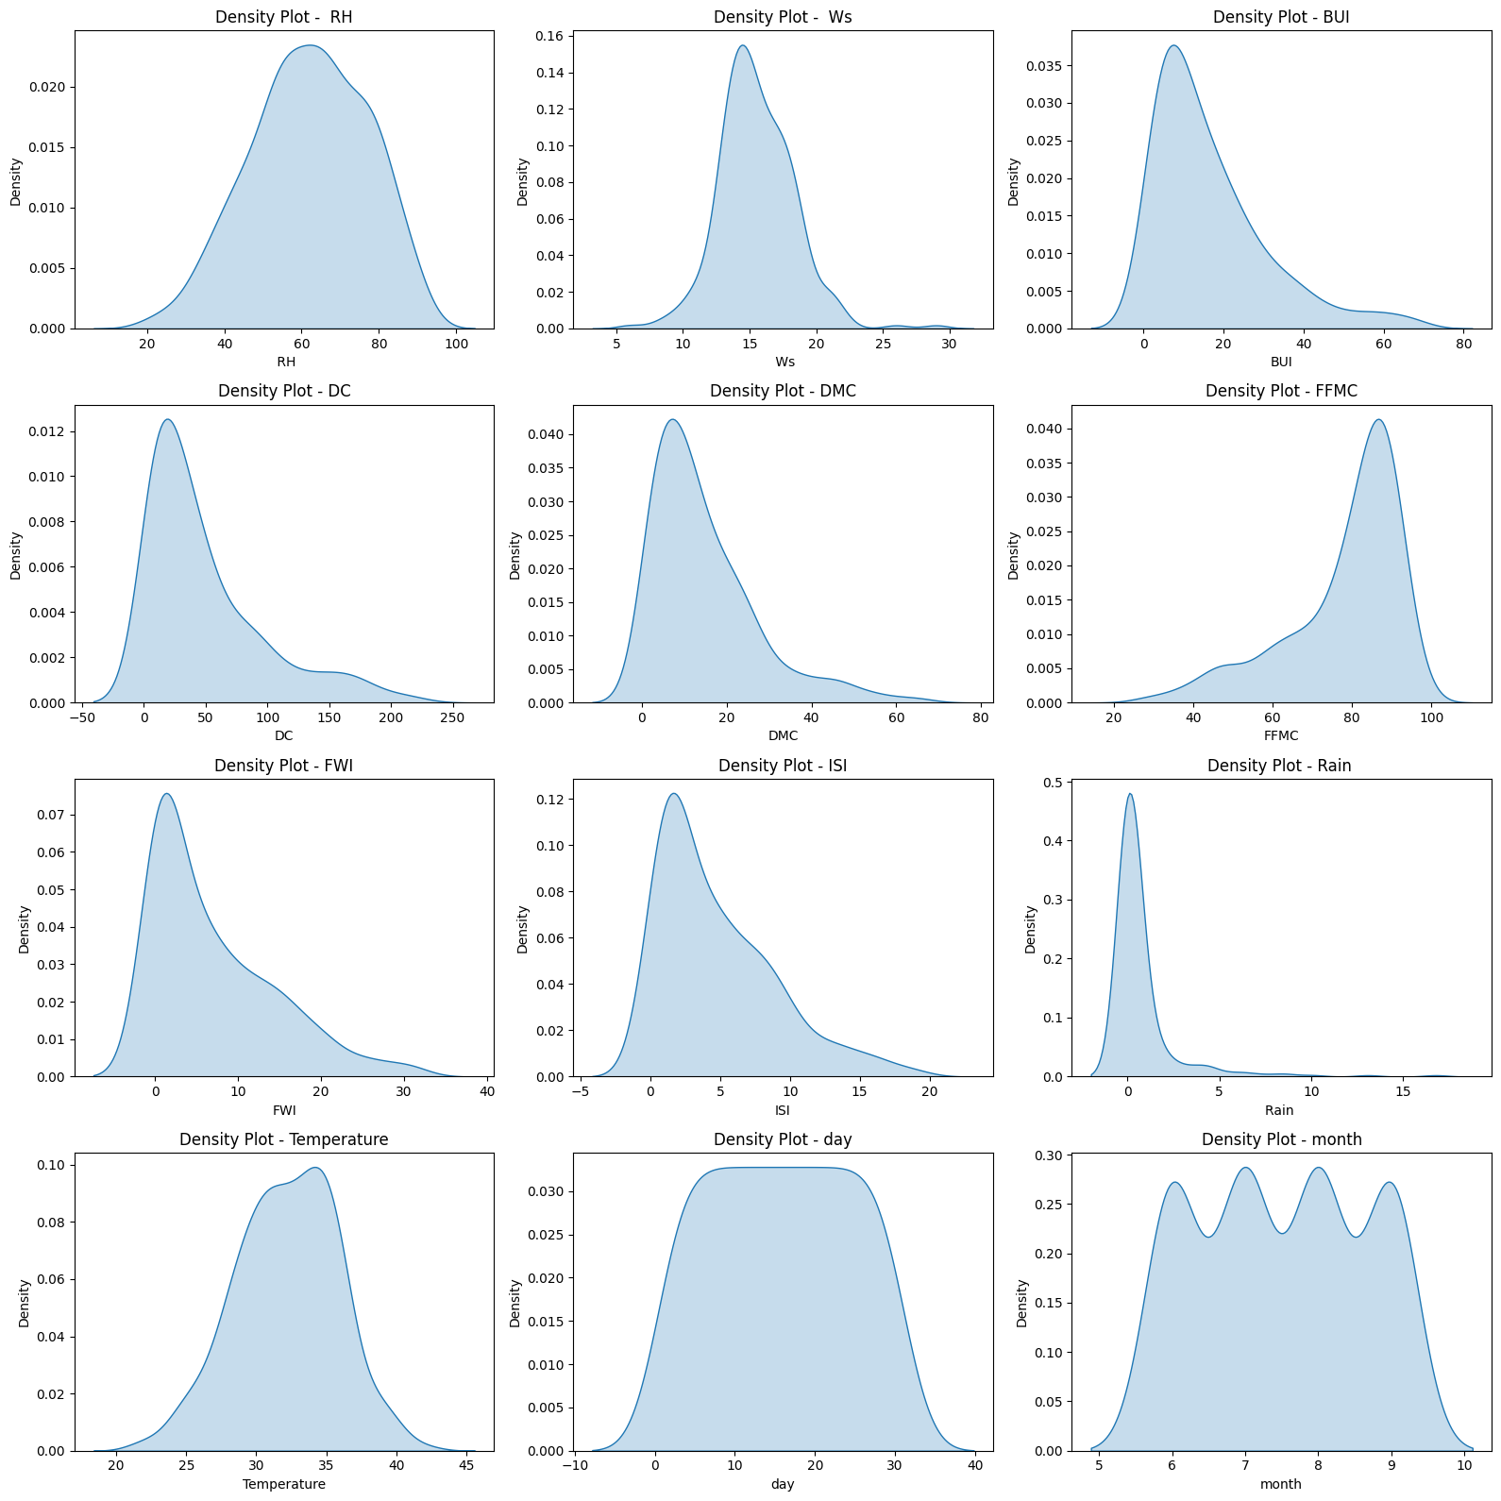

Scatter plots are essential for identifying the relationship between two continuous variables. By plotting one feature on the x-axis and another on the y-axis, we can visually detect linear or non-linear correlations. For example, we use scatter plots to see how the Fire Weather Index (FWI) changes as Temperature increases. This helps in identifying potential predictors for our regression model.
Technical Implementation: Created using plt.scatter() or sns.scatterplot().
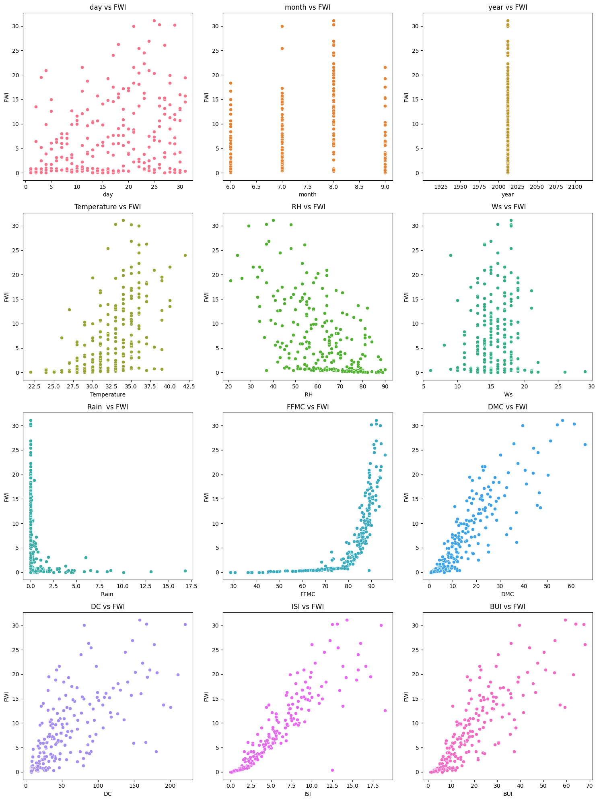

The Pairplot is one of the most powerful tools in our EDA toolbox. It creates a matrix of plots where every numeric variable is plotted against every other variable. The diagonal of the matrix usually shows the distribution of a single variable, while the off-diagonal plots show scatter plots. This gives us a "bird's-eye view" of the entire dataset's relationships in a single visualization.
Technical Implementation: Implemented via sns.pairplot(data). We often color-code this plot by the 'Classes' variable (Fire vs. Not Fire) to see how different groups cluster.

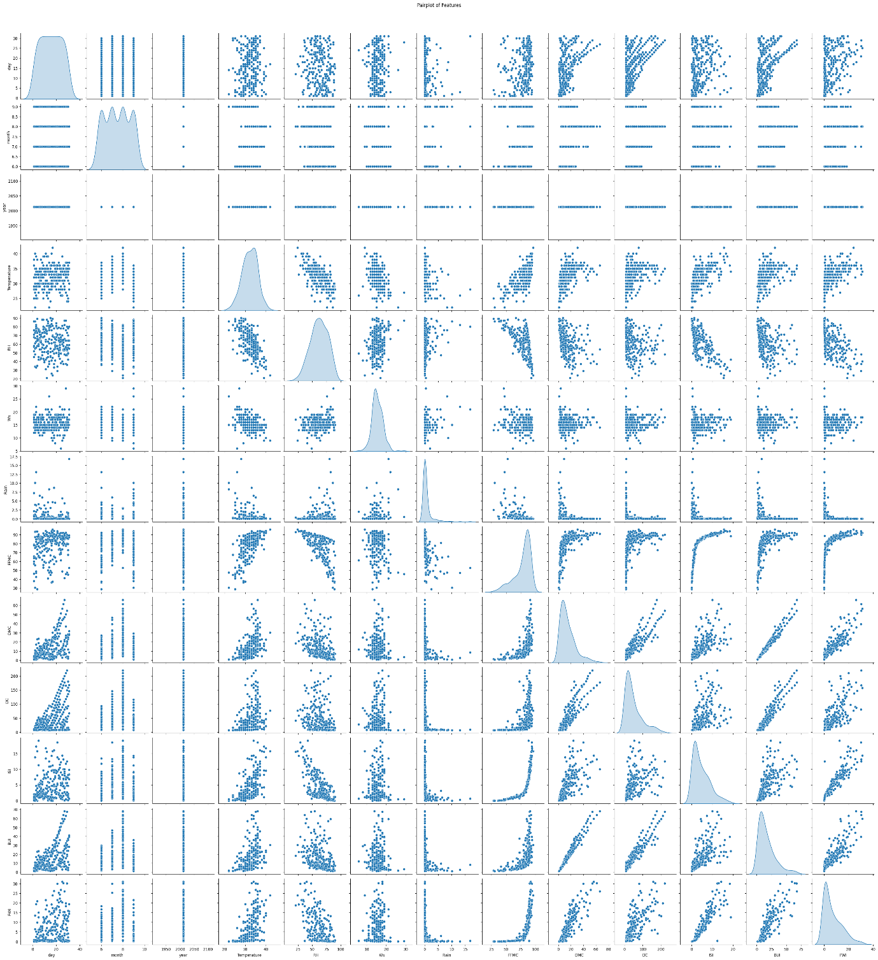
Subplots allow us to organize multiple related charts into a single organized figure (rows and columns). This is particularly useful for comparing the distributions of all independent variables side-by-side, ensuring the documentation remains clean and comparable.
Technical Implementation: We use plt.subplots(nrows, ncols) to define the layout and then assign specific plots to each "axis" index.
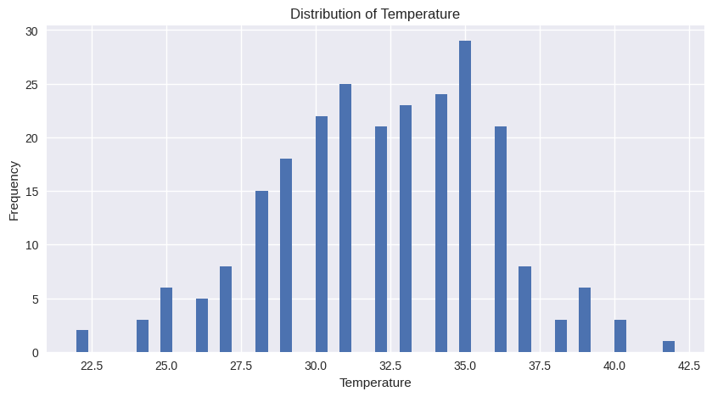
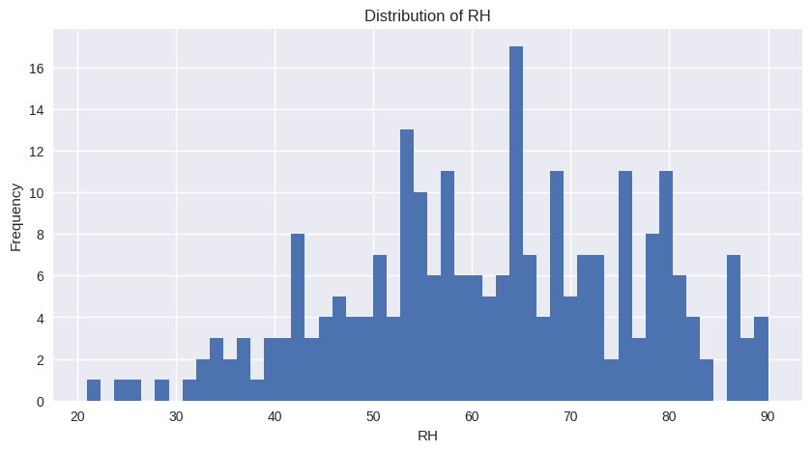
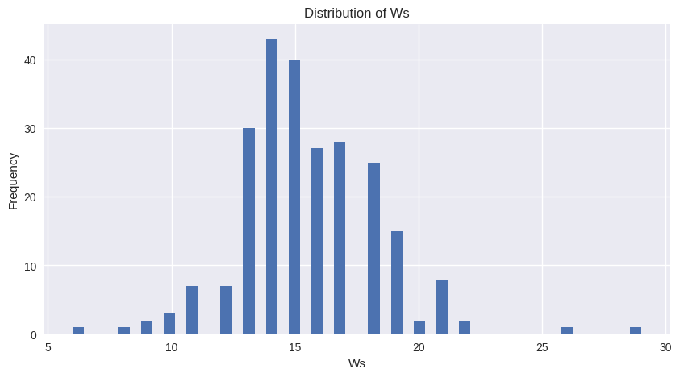
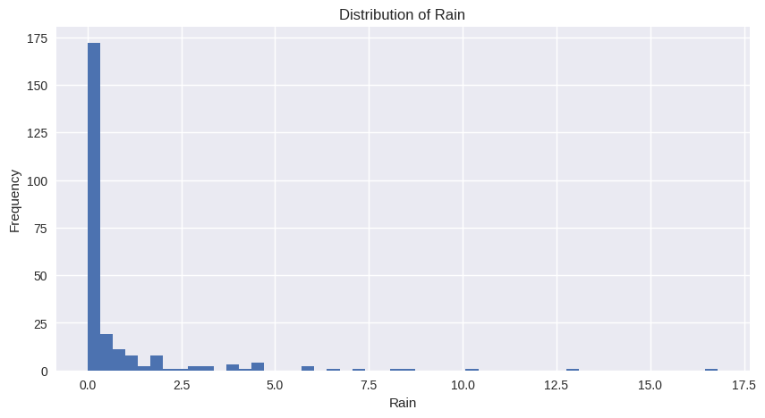
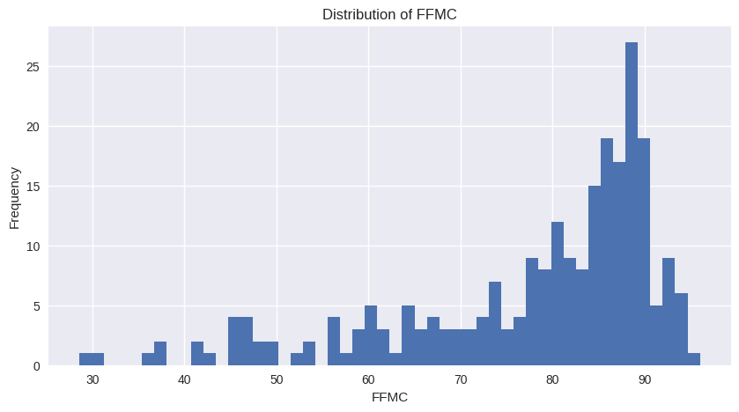
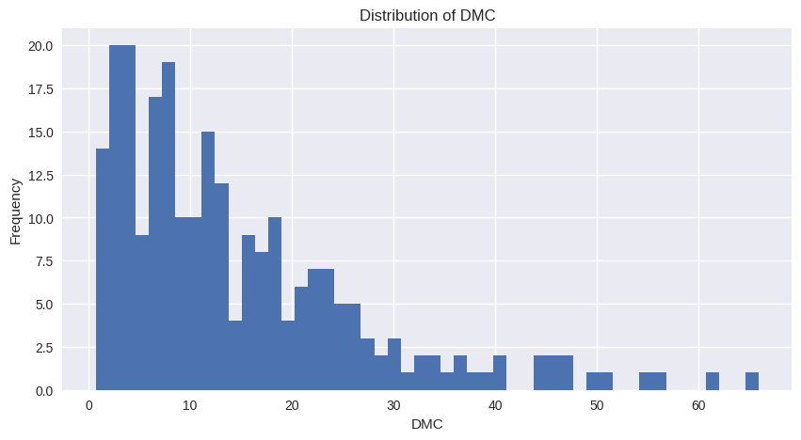
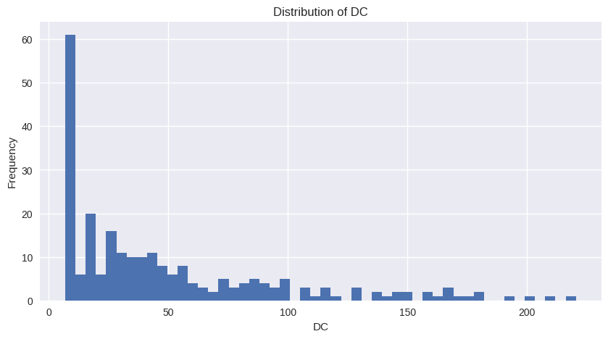
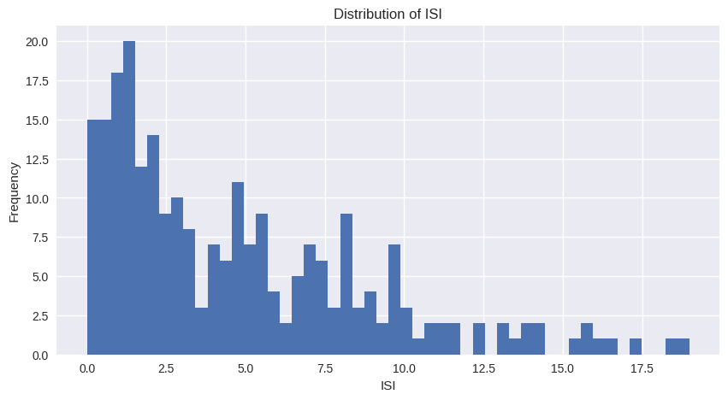

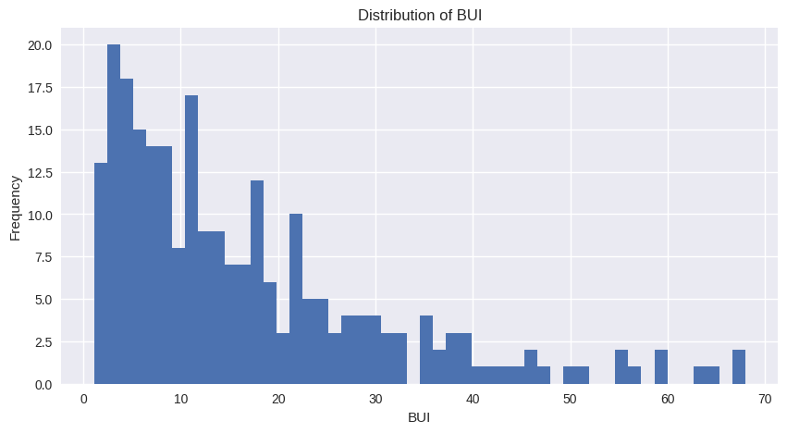
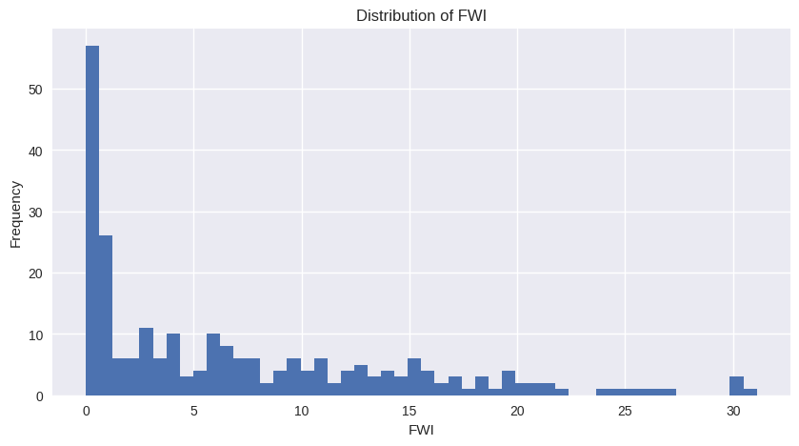
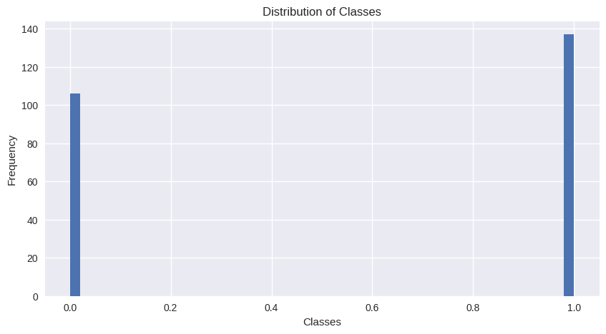

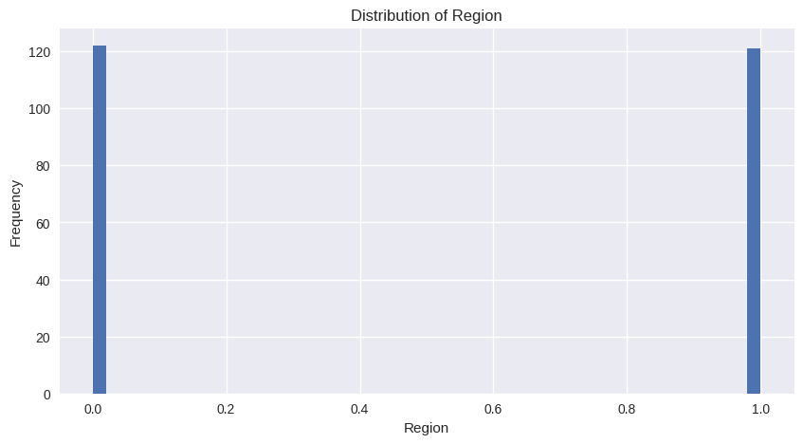

- Compute the correlation matrix for numerical features

A correlation matrix was generated to explore relationships among numerical features and identify which variables influence each other most strongly. The heatmap revealed that fire danger indices such as BUI, DMC, FFMC, and ISI have high positive correlations with each other and with Temperature, indicating shared patterns in fire behavior. Relative Humidity showed strong negative correlations with several indices, reflecting its inverse effect on fire risk. These insights helped highlight key predictive features for the Fire Weather Index and guided feature selection for modeling.
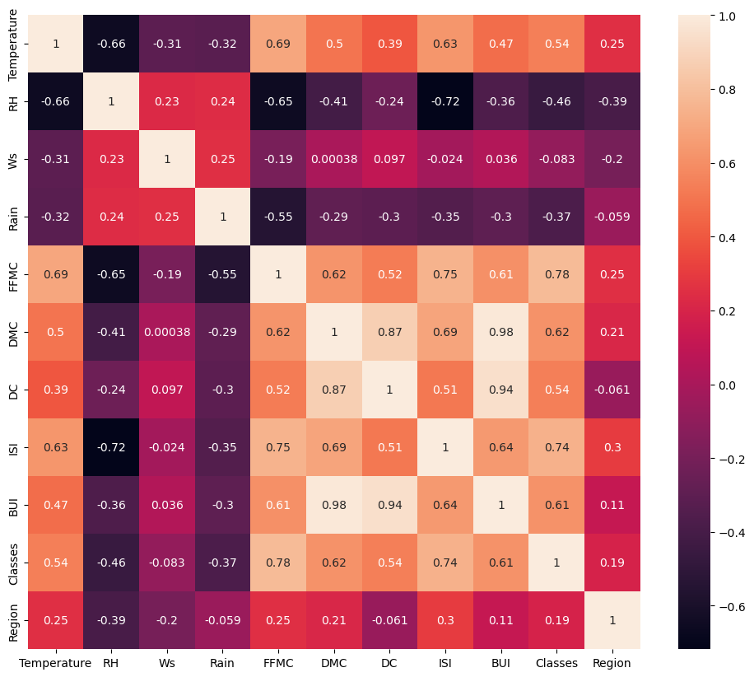

FIG 5: Correlation matrix

- Boxplots for Outlier Detection
Description: Boxplots are our primary tool for visual statistical analysis. They provide a standardized way of displaying the distribution of data based on a five-number summary: minimum, first quartile (Q1), median, third quartile (Q3), and maximum. In this dataset, we use boxplots to identify outliers—values that fall significantly outside the expected range—which is crucial for cleaning the weather data before training our machine learning models.
Technical Implementation: We implement this using sns.boxplot() or plt.boxplot(). These plots are especially useful for comparing the spread of features like Wind Speed or Rain across different months or fire classes.
Key Insights from the Notebook:
- The central "box" represents the Interquartile Range (IQR), containing the middle 50% of the data.
- The line inside the box marks the Median value.
- Individual dots appearing outside the "whiskers" indicate potential anomalies in weather recording that required investigation.
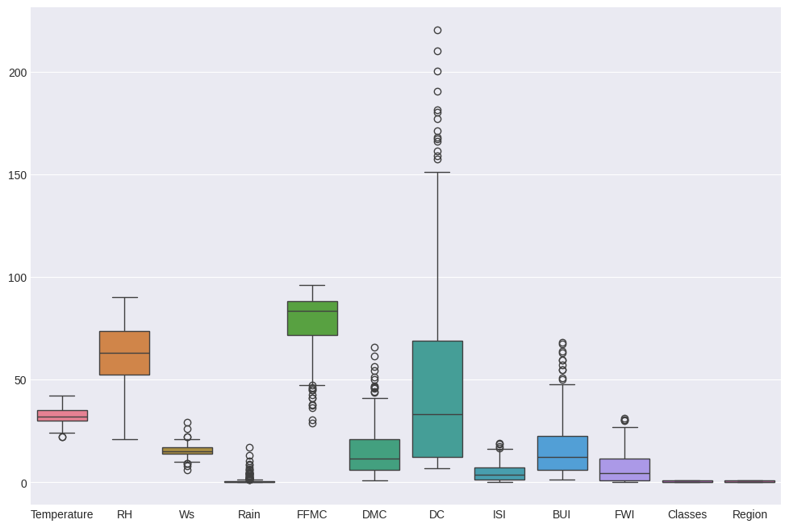

data.to_csv("C:\Users\Admin\Desktop\cleaned_FWI_dataset.csv", index=False)
print("Cleaned data saved successfully!")

Cleaned data saved successfully!

Milestone 2(Week 3,4)

- Module 3 (Feature Engineering and Scaling)
In this module, the dataset was prepared for model training by applying feature engineering and scaling techniques. The main aim of this step was to improve data quality and ensure better performance of the machine learning model. First, the important input features were selected based on their relationship with the target variable, Fire Weather Index (FWI). By choosing only the most relevant features, unnecessary columns were removed, which helped in reducing complexity and improving the efficiency of the model. After selecting the features, numerical data was scaled using StandardScaler. Since the dataset contained values in different ranges, scaling was necessary to bring all features to a common scale. This step ensured that each feature contributed equally during model training and prevented bias towards features with larger values. Once scaling was completed, the dataset was divided into input variables (X) and the output variable (y). The data was then split into training and testing sets using the train_test_split method. This allowed the model to be trained on one portion of the data and tested on unseen data for proper evaluation.Finally, the fitted scaler was saved as a .pkl file. Saving the scaler ensures that the same preprocessing steps can be applied to new data during deployment, maintaining consistency between training and real-time predictions.
- Feature Selection

from sklearn.pipeline import Pipeline
from sklearn.preprocessing import StandardScaler
from sklearn.metrics import mean_squared_error, r2_score, mean_absolute_error
from sklearn.model_selection import cross_val_score

pipeline = Pipeline([
('scaler', StandardScaler()),
('model', model)
])

pipeline.fit(X_train, y_train)

y_pred = pipeline.predict(X_test)

rmse = mean_squared_error(y_test, y_pred, squared=False)
mae = mean_absolute_error(y_test, y_pred)
r2 = r2_score(y_test, y_pred)

print("RMSE:", rmse)
print("MAE:", mae)
print("R2 Score:", r2)

cv_scores = cross_val_score(pipeline, X_train, y_train, cv=5, scoring='r2')
print("Cross-Validation R2 Mean:", cv_scores.mean())

data1['FWI'] = pd.to_numeric(data1['FWI'], errors='coerce')
data1 = data1.dropna(subset=['FWI'])
threshold = 0.3

correlation = data1.corr()[['FWI']].abs()
selected_features = correlation[correlation > threshold].index.drop('FWI')

print("Selected Features:")
print(set(selected_features))

X = data1[list(selected_features)]
y = data1['FWI']

X = X.apply(pd.to_numeric, errors='coerce')

# handle missing values
X = X.fillna(X.mean())
print(X.isnull().sum())

print("Input Features Shape:", X.shape)
print("Target Shape:", y.shape)

Temperature 0
RH 0
Ws 0
Rain 0
FFMC 0
DMC 0
DC 0
ISI 0
BUI 0
dtype: int64
Input Features Shape: (244, 9)
Target Shape: (244,)

#correlation
data1['DC'] = pd.to_numeric(data1['DC'], errors='coerce')
data1['FWI'] = pd.to_numeric(data1['FWI'], errors='coerce')

corrWithFwi = (
data1[list(selected_features) + ['FWI']]
.corr()['FWI']
.sort_values(ascending=False)
)

print("Correlation of selected features :")
print(corrWithFwi)

Correlation of selected features :
FWI 1.000000
ISI 0.908054
DMC 0.874924
BUI 0.857847
DC 0.740175
FFMC 0.686342
Temperature 0.558800
Ws 0.029001
Rain -0.322810
RH -0.570483
Name: FWI, dtype: float64

X_train, X_test, y_train, y_test = train_test_split(
X, y,
test_size=0.25, random_state=42, shuffle=True,
random_state=42
)

print("Training Data:", X_train.shape)
print("Testing Data:", X_test.shape)

Training Data: (195, 9)
Testing Data: (49, 9)

- Standard Scaler Application and train_test_split

from sklearn.pipeline import Pipeline
from sklearn.preprocessing import StandardScaler
from sklearn.metrics import mean_squared_error, r2_score, mean_absolute_error
from sklearn.model_selection import cross_val_score

pipeline = Pipeline([
('scaler', StandardScaler()),
('model', model)
])

pipeline.fit(X_train, y_train)

y_pred = pipeline.predict(X_test)

rmse = mean_squared_error(y_test, y_pred, squared=False)
mae = mean_absolute_error(y_test, y_pred)
r2 = r2_score(y_test, y_pred)

print("RMSE:", rmse)
print("MAE:", mae)
print("R2 Score:", r2)

cv_scores = cross_val_score(pipeline, X_train, y_train, cv=5, scoring='r2')
print("Cross-Validation R2 Mean:", cv_scores.mean())

Temperature int64
RH int64
Ws int64
Rain float64
FFMC float64
DMC float64
DC float64
ISI float64
BUI float64
dtype: object

4. Module 4 (Model Training using Ridge Regression)
After the initial data exploration and preprocessing of the Algerian Forest Fire dataset, we implemented Ridge Regression to predict the Fire Weather Index (FWI). We selected Ridge Regression specifically to address potential multicollinearity among weather variables (Temperature, RH, Ws, and Rain). By applying an $L2$ regularization penalty, the model shrinks the coefficients of less significant features, which prevents overfitting and ensures that the model generalizes well to unseen environmental data.

The model training process involved a systematic search for the optimal Alpha ($\alpha$)—the regularization strength. A higher alpha increases the penalty on the coefficients, leading to a simpler model.
- Training Approach: We utilized a range of alpha values to identify the point where the model maintains high accuracy without succumbing to the high variance typical of standard Linear Regression.
- Best Parameters: Based on our iterative testing, the optimal performance was achieved at a specific alpha level that balanced the bias-variance tradeoff effectively.

- Model Training and Model Evaluation
from sklearn.linear_model import Ridge
from sklearn.metrics import mean_squared_error, r2_score
import pickle

ridge_model = Ridge(alpha=1.0)
ridge_model.fit(X_train_scaled, y_train)

Hyperparameter Tuning

alphas = [0.01, 0.1, 1, 10, 100]
results = {}

for a in alphas:
model = Ridge(alpha=a)
model.fit(X_train_scaled, y_train)
y_pred = model.predict(X_test_scaled)
results[a] = r2_score(y_test, y_pred)

results

{0.01: 0.9862061868814829,
0.1: 0.9862705150140384,
1: 0.9859555623886314,
10: 0.975455594324904,
100: 0.897376719683076}

# model evaluation
y_train_pred = ridge_model.predict(X_train_scaled)
y_test_pred = ridge_model.predict(X_test_scaled)

print("Training R² Score:", r2_score(y_train, y_train_pred))
print("Testing R² Score:", r2_score(y_test, y_test_pred))
print("Testing MSE:", mean_squared_error(y_test, y_test_pred))

accuracy = ridge_model.score(X_test_scaled, y_test)
print("Model Accuracy:", accuracy)

Training R² Score: 0.9560578008746927
Testing R² Score: 0.9859555623886314
Testing MSE: 0.5473954387971778
Model Accuracy: 0.9859555623886314

Milestone 3(Week 5,6)

Module 5 (Evaluation and Optimization)

This implementation uses a Pipeline based approach, includes cross-validation, and evaluates performance using multiple regression metrics for robustness.

1.Linear Regression- A linear regression model is a statistical method used to predict the value of a continuous variable (dependent variable) based on one or more predictor variables (independent variables).
linear_model = LinearRegression()
linear_model.fit(X_train_scaled, y_train)

with open('linear.pkl', 'wb') as file:
pickle.dump(linear_model, file)
print("Linear Regression model saved successfully.")

accuracy = linear_model.score(X_test_scaled, y_test)
print("Model Accuracy:", accuracy)

Linear Regression model saved successfully.
Model Accuracy: 0.9861963876930295

2.Lasso Regression- Lasso regression (Least Absolute Shrinkage and Selection Operator) is a linear regression technique used in the project to predict the Fire Weather Index (FWI).
Lasso_model = Lasso(alpha=0.1)
Lasso_model.fit(X_train_scaled, y_train)

with open('lasso.pkl', 'wb') as file:
pickle.dump(Lasso_model, file)
print("Lasso Regression model saved successfully.")

accuracy = Lasso_model.score(X_test_scaled, y_test)
print("Model Accuracy:", accuracy)

Lasso Regression model saved successfully.
Model Accuracy: 0.9807656030852773

3.Random Forest- A Random Forest is an ensemble machine learning technique that combines the predictions of multiple decision trees to produce a single, more accurate, and stable result.

random_forest = RandomForestRegressor(n_estimators=100, random_state=42)
random_forest.fit(X_train_scaled, y_train)

with open('random_forest.pkl', 'wb') as file:
pickle.dump(random_forest, file)
print("Random Forest model saved successfully.")

accuracy = random_forest.score(X_test_scaled, y_test)
print("Model Accuracy:", accuracy)

Random Forest model saved successfully.
Model Accuracy: 0.9863214909862315

import warnings
warnings.filterwarnings("ignore")
models = {
"Linear Regression": linear_model,
"Ridge Regression": ridge_model,
"Lasso Regression": Lasso_model,
"Random Forest": random_forest
}

results = []

for name, model in models.items():
y_pred = model.predict(X_test)

mae = mean_absolute_error(y_test, y_pred)
rmse = np.sqrt(mean_squared_error(y_test, y_pred))
r2 = r2_score(y_test, y_pred)

results.append([name, mae, rmse, r2])

results_df = pd.DataFrame(
results,
columns=["Model", "MAE", "RMSE", "R2 Score"]
)

print(results_df)

Model MAE RMSE R2 Score
0 Linear Regression 0.547969 0.733491 0.986196
1 Ridge Regression 0.550682 0.739862 0.985956
2 Lasso Regression 0.651793 0.865840 0.980766
3 Random Forest 0.468122 0.730160 0.986321

Random Forest is the best model as it achieves the lowest MAE and RMSE with highest R2 Score , indicating superior prediction accuracy as compared to the other models.

plt.figure(figsize=(10, 6))
sns.barplot(
data=results_df.melt(id_vars="Model",
value_vars=["MAE", "RMSE"]),
x="Model",
y="value",
hue="variable",
palette="Set2"
)

plt.title("Model Error Comparison")
plt.ylabel("Error Value")
plt.xticks(rotation=15)
plt.show()

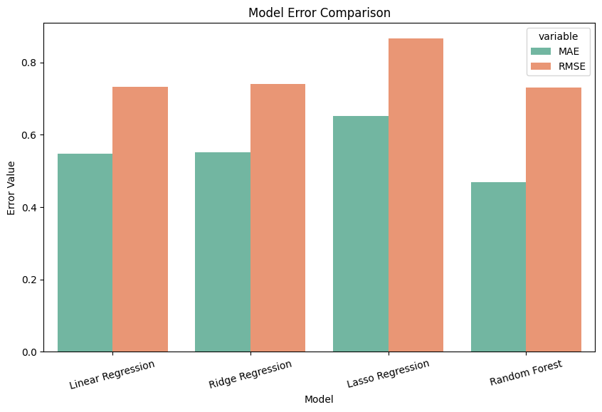

Model Performance

import warnings
warnings.filterwarnings("ignore")
plt.figure(figsize=(8, 5))
sns.barplot(
data=results_df,
x="Model",
y="R2 Score",
palette="viridis"
)

plt.title("Model Performance (R² Score)")
plt.ylabel("R² Score")
plt.xticks(rotation=15)
plt.show()

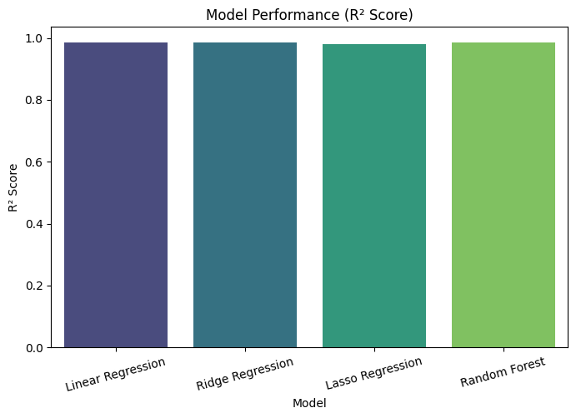
Actual VS Predicted Plot

for name, model in models.items():
model.fit(X_train_scaled, y_train)
y_pred = model.predict(X_test_scaled)

plt.figure(figsize=(7, 7))
sns.scatterplot(
x=y_test,
y=y_pred,
alpha=0.7
)

plt.plot(
[y_test.min(), y_test.max()],
[y_test.min(), y_test.max()],
'r--'
)

plt.xlabel("Actual FWI")
plt.ylabel("Predicted FWI")
plt.title(f"Actual vs Predicted FWI ({name})")
plt.show()

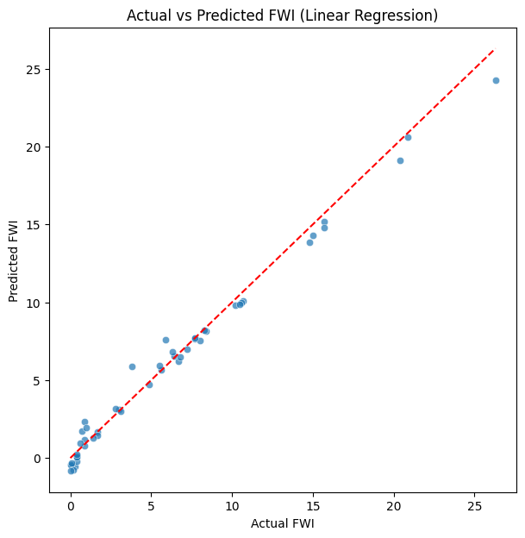

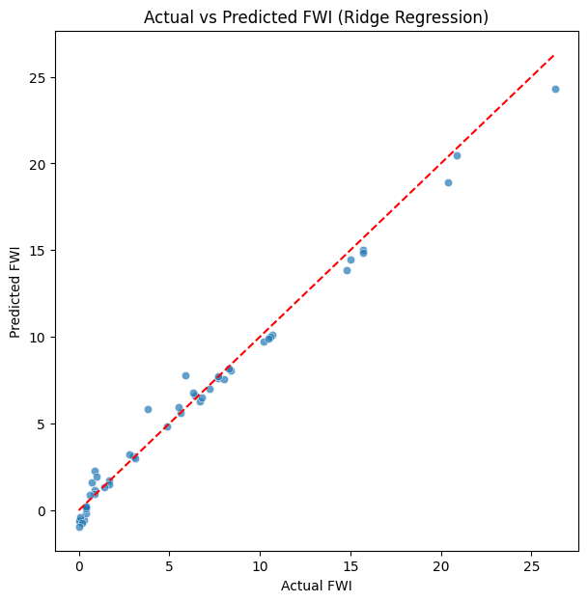

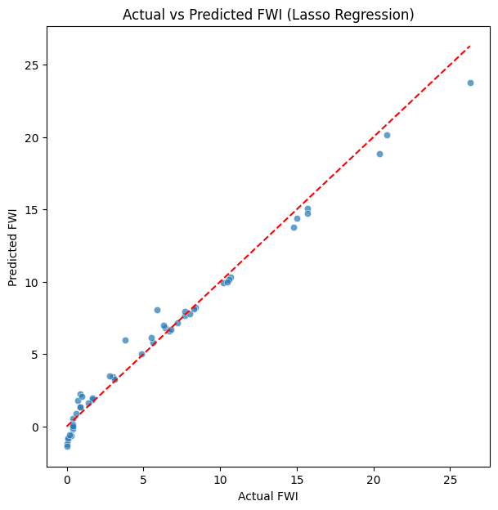

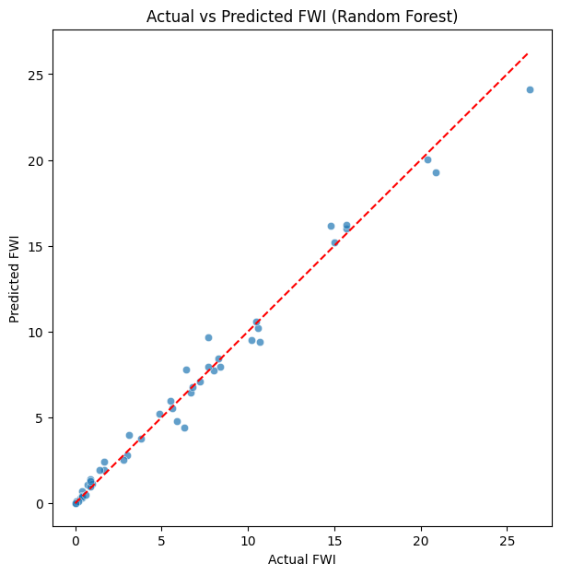

Tuning Model Parameter(Alpha) and Retraining if needed

alphas = [0.001, 0.01, 0.1, 1, 10, 100]
ridge_results = []

for a in alphas:
ridge = Ridge(alpha=a)
ridge.fit(X_train_scaled, y_train)
y_pred = ridge.predict(X_test_scaled)

ridge_results.append([
a,
mean_absolute_error(y_test, y_pred),
np.sqrt(mean_squared_error(y_test, y_pred)),
r2_score(y_test, y_pred)
])

ridge_df = pd.DataFrame(
ridge_results,
columns=["Alpha", "MAE", "RMSE", "R2 Score"]
)

ridge_df

best_alpha = ridge_df.loc[ridge_df["RMSE"].idxmin(), "Alpha"]

best_ridge = Ridge(alpha=best_alpha)
best_ridge.fit(X_train_scaled, y_train)

y_pred_best_ridge = best_ridge.predict(X_test_scaled)

Plot Tuned Ridge Performance

plt.figure(figsize=(6,6))
plt.scatter(y_test, y_pred_best_ridge, alpha=0.7)
plt.plot(
[y_test.min(), y_test.max()],
[y_test.min(), y_test.max()],
'r--'
)
plt.xlabel("Actual FWI")
plt.ylabel("Predicted FWI")
plt.title(f"Tuned Ridge Regression (alpha={best_alpha})")
plt.show()

# Accuracy of the tuned model
accuracy = best_ridge.score(X_test_scaled, y_test)
print("Tuned Ridge Regression Model Accuracy:", accuracy)

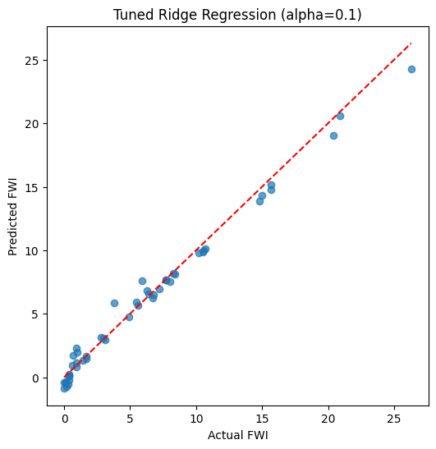

Tuned Ridge Regression Model Accuracy: 0.9862705150140384

Comparison before and after tuning of Ridge Regression Model

comparison_df = pd.DataFrame({
"Model": ["Ridge (Before Tuning)", "Ridge (After Tuning)"],
"MAE": [
0.550682,

ridge_df.loc[ridge_df["Alpha"] == best_alpha, "MAE"].values[0]
],
"RMSE": [
0.739862,
ridge_df.loc[ridge_df["Alpha"] == best_alpha, "RMSE"].values[0]
],
"R2 Score": [
0.985956,
ridge_df.loc[ridge_df["Alpha"] == best_alpha, "R2 Score"].values[0]
]
})

comparison_df

Save the .pkl file

with open("ridge.pkl", "wb") as file:
pickle.dump(ridge_model, file)

Milestone 4(Week 7,8)

Module 6 (Deployment via Flask App)

The objective of this milestone was to transition the trained Ridge Regression model from a research environment into a functional web application. The application allows users to input real-time weather parameters and receive an immediate prediction of the FWI and its associated risk level.
The deployment follows a standard Model-View-Controller (MVC) pattern adapted for Flask:

a.The Model: ridge.pkl (The trained regression model) and scaler.pkl (Pre-trained StandardScaler).
b.The Controller: app.py, which manages routing, data collection, and processing logic.
c.The View: index.html, a responsive interface for user interaction.

TECHNICAL IMPLEMENTATION

Backend Development

The backend serves as the bridge between the machine learning model and the web interface.
- Environment Setup: The application uses os.path to define a BASE_DIR, ensuring that the pickle files are located correctly regardless of where the script is executed.
- Model Loading: Upon startup, the app loads ridge.pkl and scaler.pkl using the pickle library. Loading these at the start of the runtime ensures faster response times during individual user requests.
- Request Handling: The /predict route is configured specifically to handle POST methods. It extracts nine specific features from the HTML form: Temperature, RH, Wind, Rain, FFMC, DMC, DC, BUI, and ISI.
- Preprocessing and Inference: Because the Ridge model was trained on scaled data, the input values are first converted to a float list and then passed through scaler.transform() before calling model.predict().

from flask import Flask, render_template, request
import pickle
import os
import numpy as np

# Initialize Flask app FIRST to avoid NameError
app = Flask(__name__)

# Define base directory for file paths
BASE_DIR = os.path.dirname(os.path.abspath(__file__))

# Load the model and scaler using absolute paths
model = pickle.load(open(os.path.join(BASE_DIR, 'ridge.pkl'), 'rb'))
scaler = pickle.load(open(os.path.join(BASE_DIR, 'scaler.pkl'), 'rb'))

@app.route('/')
def home():
"""Renders the main input form."""
return render_template('index.html')

@app.route('/predict', methods=['POST'])
def predict():
"""Handles form submission, scaling, and prediction."""
try:
# 1. Extract features from form in the exact order required by the model
# Note: If your model was trained on 7 or 8 features, adjust this list
feature_keys = ['Temperature', 'RH', 'Wind', 'Rain', 'FFMC', 'DMC', 'DC', 'BUI', 'ISI']

# Convert form values to floats
raw_values = [float(request.form[x]) for x in feature_keys]

# 2. Scale the data using the pre-loaded StandardScaler
scaled_data = scaler.transform([raw_values])

# 3. Generate prediction [cite: 3]
prediction = model.predict(scaled_data)
fwi = prediction[0]

# Debugging: Print to console to see the raw FWI value
print(f"Calculated FWI: {fwi}")

# 4. Logic for Risk Categorization
if fwi <= 7:
risk = "Low 🔵"
elif fwi <= 16:
risk = "Moderate 🟡"
elif fwi <= 31:
risk = "High 🟠"
else:
risk = "Extreme 🔴"

return render_template('index.html', prediction=round(fwi, 2), risk=risk)

except Exception as e:
return f"An error occurred: {str(e)}. Please check your input values."

if __name__ == '__main__':
app.run(debug=True)

Frontend Implementation

The user interface is a single-page application (SPA) style design built with HTML5 and CSS3.
- Input Validation: Each <input> tag includes a required attribute to prevent the application from attempting a prediction with missing data.
- User Feedback: The UI utilizes Jinja2 syntax ({% if prediction %}) to dynamically update the page. This means the "FWI Value" and "Risk Level" sections remain hidden until the user clicks the "Predict" button.
- Styling: A dark-themed CSS interface was implemented using a background gradient (#0f2027) and high-contrast orange buttons to ensure a modern, user-friendly experience.
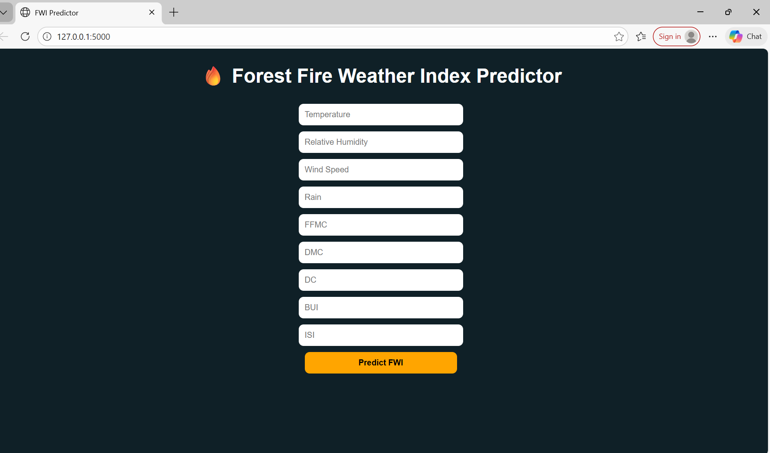

Data Pipeline and Logic Flow

The system processes data in a linear pipeline to ensure mathematical accuracy.
- Input: User enters raw meteorological data into the web form.
- Normalization: The StandardScaler (via scaler.pkl) centers the data around a mean and scales it to unit variance.
- Prediction: The Ridge regression model processes the scaled array to output a continuous FWI value.
- Classification: A conditional logic block translates the numerical FWI into a color-coded categorical risk (Low, Moderate, High, or Extreme).
FOR LOW FWI VALUE
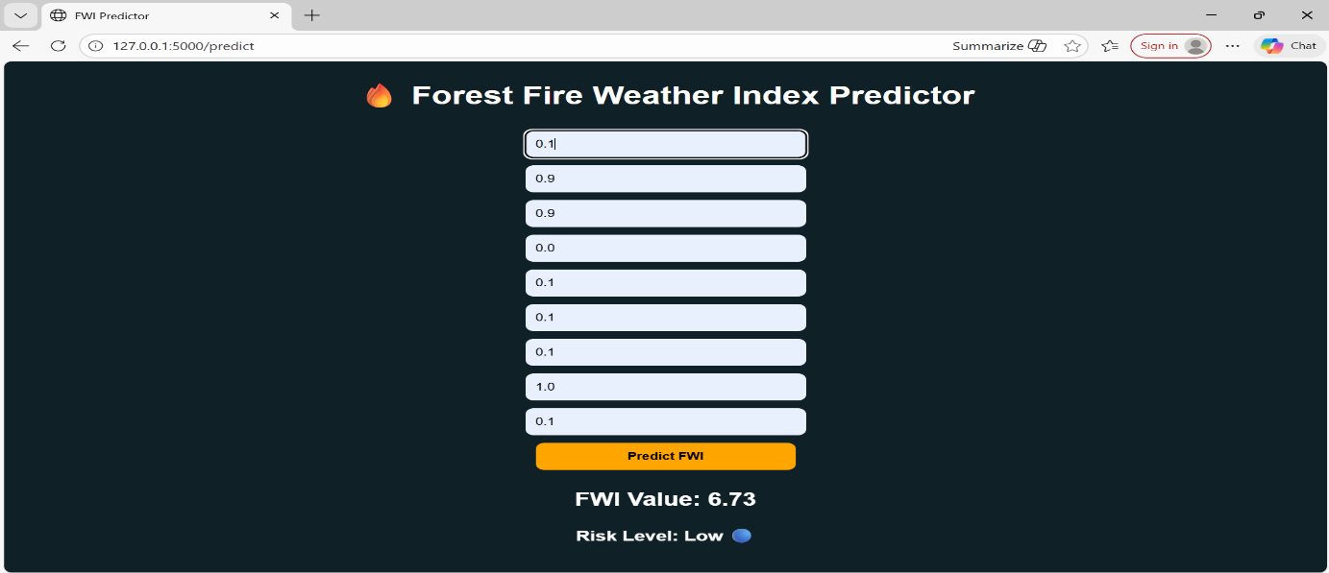
FOR MODERATE FWI VALUE
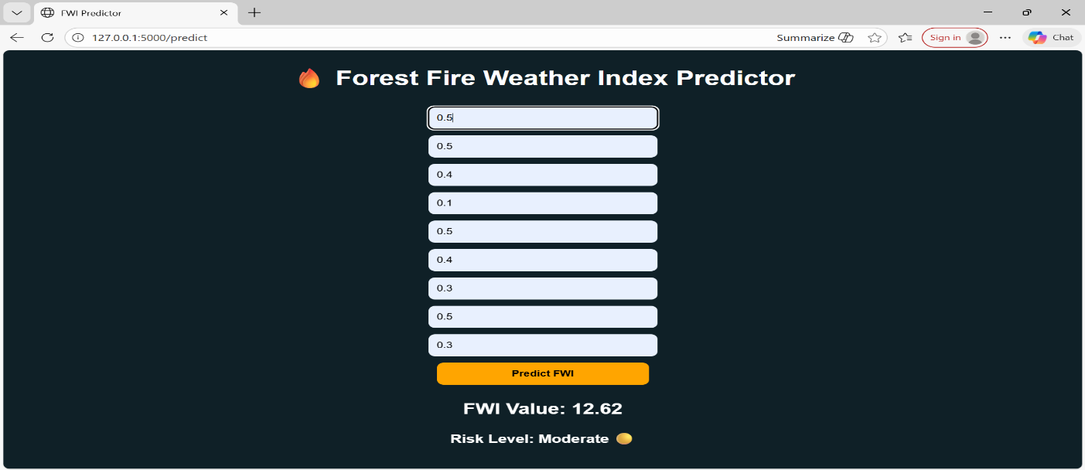
FOR HIGH FWI VALUE
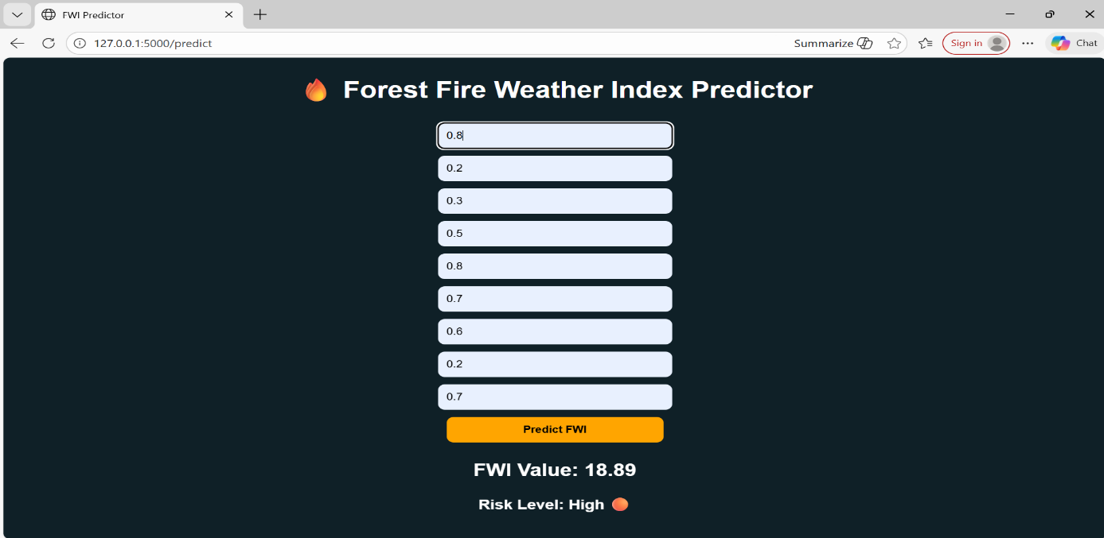
FOR EXTREME FWI VALUE
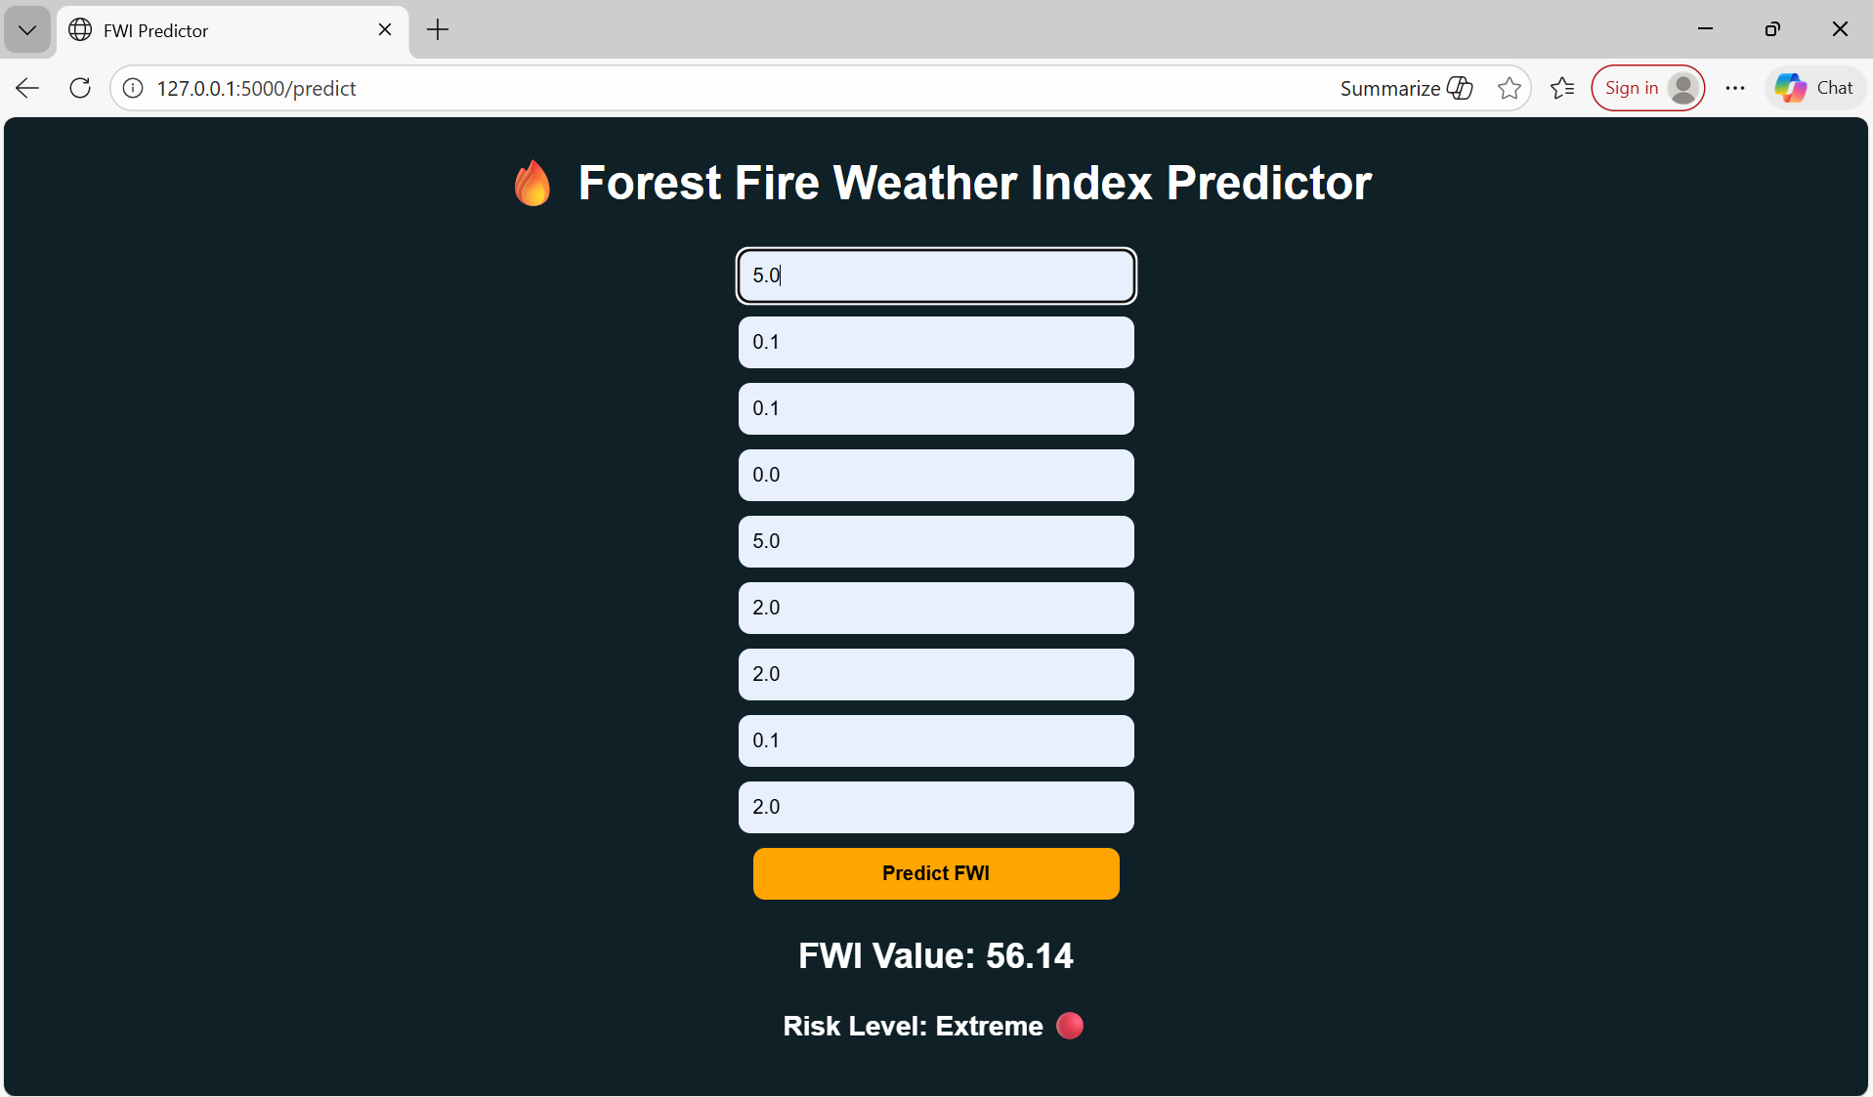

Deployment Configuration
To prepare for a production environment, a requirements.txt file was generated to manage the virtual environment.
- Library Dependencies: The file explicitly lists flask, numpy, scikit-learn, and gunicorn.
- Production Server: gunicorn is included as the WSGI (Web Server Gateway Interface) to handle multiple concurrent requests, which is more secure and stable than the built-in Flask development server.
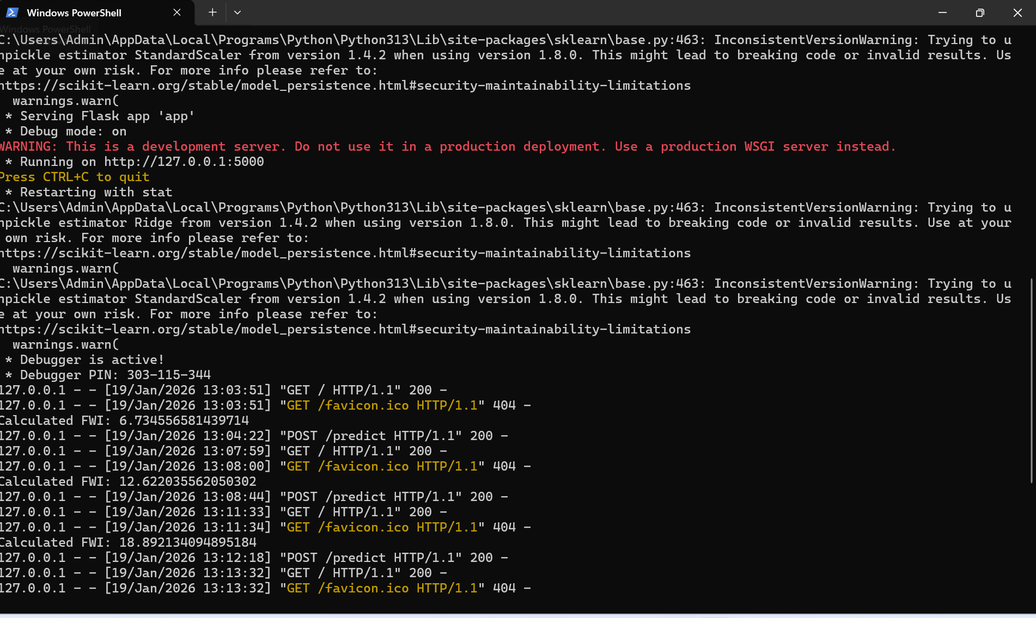

Conclusion- Milestone 4 successfully demonstrates the end-to-end deployment pipeline. The application is now capable of taking raw environmental data and producing an actionable wildfire risk assessment in real-time.

